Today’s Date: _______________________ Date of Birth: _______________________

Patient Name: ___________________________________________________________________ Age: ______ Height: ______ Weight: _____
Last Name First Name Middle Initial

Warning: The MRI magnet is ALWAYS ON. Certain implants, devices or objects may be hazardous to you and/or may interfere with the MRI procedure. Consult the MRI technologist and ask any questions before entering the MRI room for your exam.

Please check yes or no on the following questions. |  |  | Please mark where your pain in located on the
Yes | No | Cardiac Pacemaker, internal electrodes or wires | diagram below:
Yes | No | Brain aneurysm clip(s) | 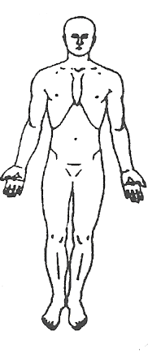 | 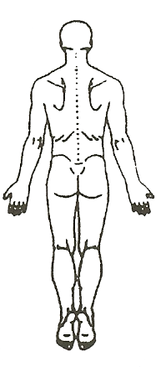
Yes | No | Implanted cardioverter defibrillator
Yes | No | Electronic implant or device
Yes | No | Neurostimulation device
**If yes to any of the questions above please stop, you cannot have an MRI.**
Yes | No | Are you on dialysis
Yes | No | Any history of metal work, welding or grinding
Yes | No | Bone growth stimulator
Yes | No | Insulin or other infusion pump
Yes | No | Any type of prosthesis (penile, limb, etc.)
Yes | No | Shunt
Yes | No | Metallic stent, filter or coil
Yes | No | Swan-Ganz catheter
Yes | No | Tissue Expander (e.g. breast)
Yes | No | Medication patches
Yes | No | Any metallic fragment or shrapnel within your body
Yes | No | Cochlear implant, cataract surg or eyelid spring/wire | Please list any surgeries you have had on the  area being scanned today:
Yes | No | Body piercings, tattoos, permanent makeup
Yes | No | Removable dental work (Remove before MRI)
Yes | No | Hearing Aids (Remove before MRI)
Yes | No | Claustrophobic
Yes | No | Breathing problem or motion disorder
Yes | No | Reaction to MRI Gadolinium contrast
Yes | No | Other: ___________________________________
Women Only |  | Are you pregnant or nursing: Yes No
 |  | IUD or diaphragm Yes No

Note: Hearing protection is required during the MRI exam to prevent possible problems or hazards related to acoustic noise. ___________________________________________________________________________________________

Are language interpretive services needed for this encounter? Yes No If yes, ref #: ______________________

I attest that the information above is correct to the best of my knowledge. I have read and understand the entire contents of this form and have had the opportunity to ask questions regarding the information on this form.

_________________________________________________________ _________________________________ ________________
Signature of Person Completing Form Date Time

Form completed by: Patient Relative Other – relationship to patient: ______________________________________________

Form information reviewed by: ______________________________ Signature: ______________________________________________

